EXERCISE 1

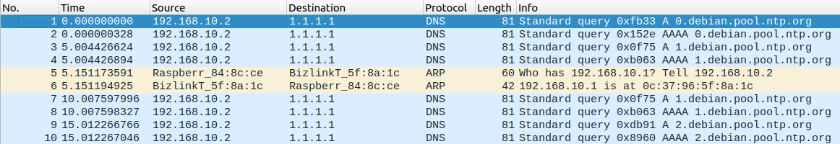
RASPBERRY PI CAPTURE
There are packets from the raspberry pi which are simple DNS queries as well as an ARP exchange connecting the IPv4 address to the Pi.

HTTP TRAFFIC CAPTURE

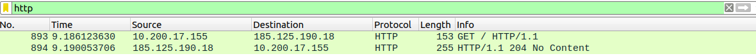
HTTP traffic was captured via filtering for it from the lab PC's traffic.

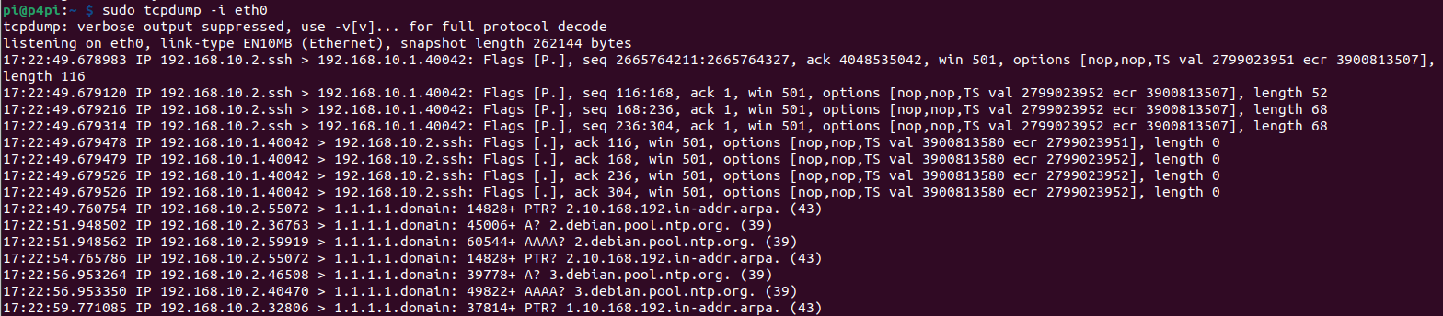
TCPDUMP CAPTURE ON PI
SENDING TRAFFIC
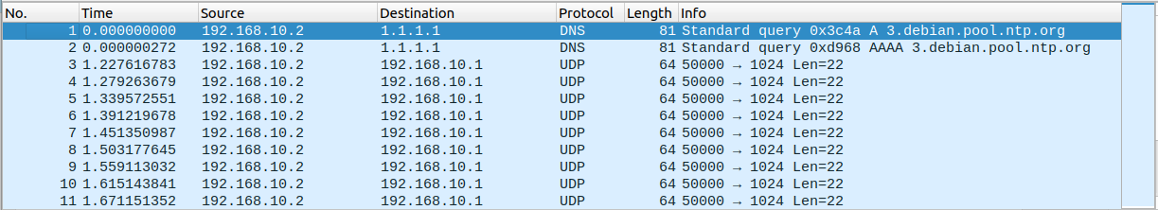
Using capture filter “src host 192.168.10.2 and udp”, the 22 bit long UDP packets can be filtered.
Python script change documented at https://github.com/Hamozwa/CWM-ProgNets

